1. 
2. In this section, we will learn how git works rather than how to use git.
3. 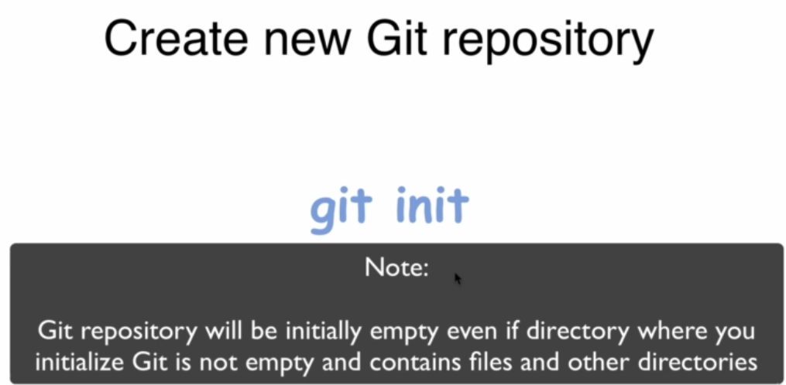
4. 
5. 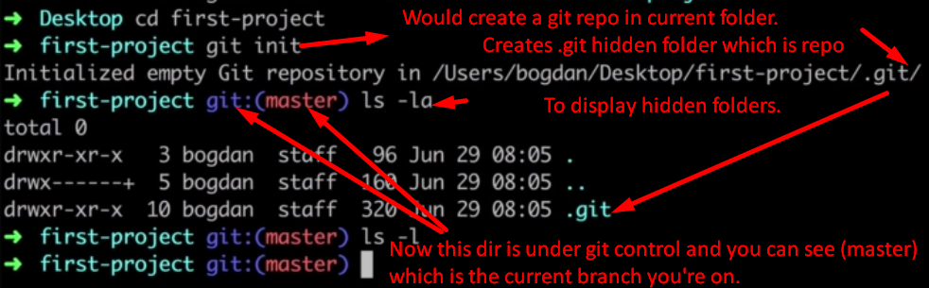
6. 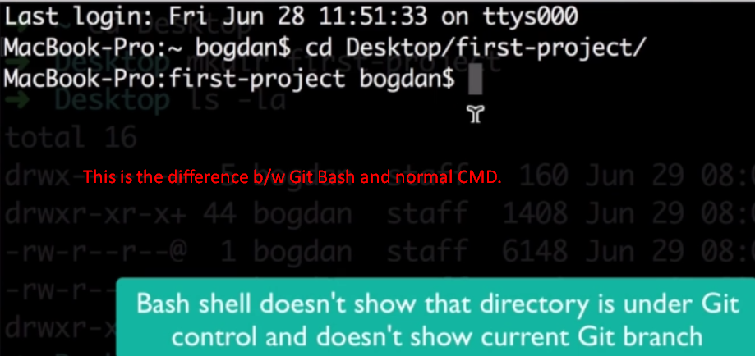
7. 